Data Structures and Algorithms  B. in Computer Engineering  B. in Robotics Engineering  Universidad Carlos III de Madrid  Course 2024-2025 | 

Group 89M. First Partial exam. March 4, 2025.

Surname, Name:………………………………………………small group:

Instructions:
- Write your name on this exam sheet.
- The duration of the exam is 75 minutes.
- Use draft papers to prepare your solution. When you are satisfied, copy your final solution on a new sheet.
- Take great care in the presentation of your solution. Your code must be clear and neat.
- If you have a question, raise your hand and wait to be answered.
- You may not leave the exam before 30 minutes have passed.
- You are not allowed to go to the bathroom.
- You are not allowed to use Python lists
- When you finish, give the teacher the exam sheet and your solution sheets.

REMEMBER THAT EACH EXERCISE MUST BE DELIVERED ON SEPARATE SHEETS.

You cannot use the class SList or DList methods unless you develop them. Your solution must be as efficient as possible.

(1 point) Problem 1: In the following SListHT class (Singly Linked List with head and tail), implement the function removeNtoM (self,n,m), which receives 2 positive integers, n and m (n<=m), that must correspond to existing indexes in the list. The method will delete the nodes between index n and index m, items with index n and m included. The method modifies the calling list (self). It doesn´t return anything.
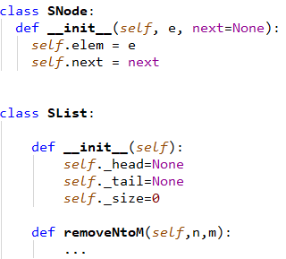

Examples:
Self before operation | operation | Self after operation
Empty | self.removeNtoM (3,4) | Empty  (indexes 3, 4 do not exist in the list)
0 (one element) | self.removeNtoM (0,0) | Empty  (element with index 0 has been removed)
0<->1<->2<->3<->4 <->5 | self.removeNtoM (2,4) | 0<->1<->5
0<->1<->2<->3<->4 <->5 | self.removeNtoM (0,5) | Empty  (all the elements have been removed)
0<->1<->2<->3<->4 <->5 | self.removeNtoM (7,9) | 0<->1<->2<->3<->4 <->5  (indexes 7, 9 do not exist in the list)
0<->1<->2<->3<->4 <->5 | self.removeNtoM (3,9) | 0<->1<->2<->3<->4 <->5  (index 9 does not exist in the list)

(0, 25 points) Estimate the order of complexity O(?) of your solution, best case and worst case. Justify your answer.
(1 point) Problem 2: In the following DList class, implement a new method, reverseHalves(). Given mid = len(self)//2, the first half of the list includes indexes 0 to mid-1, and the second half of the list consists of indexes from mid to the end of the list. The method will reverse the first half of the list (by swapping the references of the nodes) and, next, the second half (by swapping the references of the nodes). The method modifies the calling list (self). It doesn´t return anything. The reversing approach must be based on swapping references; no other approach will be evaluated.

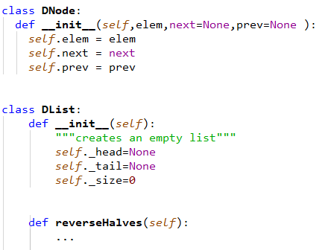
Examples:
Self before operation | operation | Self after operation
empty | self.reverseHalves() | empty
0 (one element) | self.reverseHalves() | 0 (one element)
0<->1 | self.reverseHalves() | 0<->1
0<->1<->2 | self.reverseHalves() | 0<->2<->1
0<->1<->2<->3<->4 <->5 | self.reverseHalves() | 2<->1<->0<->5 <->4<->3
0<->1<->2<->3<->4 | self.reverseHalves() | 1<->0<->4 <->3<->2

(0, 25 points) Estimate the order of complexity O(?) of your solution, best case and worst case. Justify your answer.

